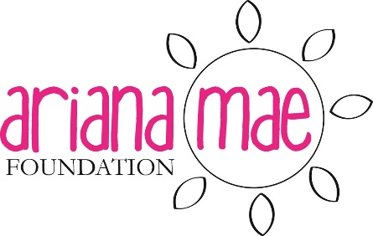
The Ariana Mae Foundation
707 Pleasant St, Grand Ledge, MI 48837
Grant Application (Bereaved Family)

Child’s Name: __________________________________ Date of Birth: ______________________
Cause of Death: ________________________________ Date of Death: _____________________
Parent(s) or Guardian(s): ________________________________________________________________
No. of other children: ____________ Ages: ___________________
Address: ______________________________________ City: _____________________________
State: _____________________ Zip: ____________ Telephone: ________________________
Email: _____________________ When is the best time to reach you? ________________________
Purpose of Application (please check one or more):
- Funeral expenses
- Financial emergency
- Uninsured medical expenses
- Memorial
- Act of Kindness (this could be a family outing, help with household tasks, a special gift for the child, etc.)
- Other
What is the amount you are requesting? ___________________________________________________
Who is the payee? _____________________________________________________________________
Additional Comments: __________________________________________________________________________________________________________________________________________________________________________
Person completing this form (if other than the parent/caregiver): _______________________________
Institution: ________________________________ Position: ________________________________
Phone: ___________________________________ Email: ___________________________________

Signature: ____________________________________________ Date: _________________________

Please send completed form to: The Ariana Mae Foundation, Attn: Kelly Lusis
707 Pleasant St., Grand Ledge, MI 48837
517-242-1327

